Group Answer Sheet – Module 10

Date:
Group Members:

1. Explain why (2), (3) and (4) involve graphemic, phonemic, and semantic processing, respectively.

2. Craik and Tulving gave subjects four positive and four negative instances of each type of question. Why did they have to give both positive and negative instances of each type?

3. When Craik and Tulving conducted the experiment, they assigned words to each of ten possible combinations of question and answer which was rotated across subjects. What are these 10 combinations? List them.

4. Craik and Tulving’s data are given in the table below. 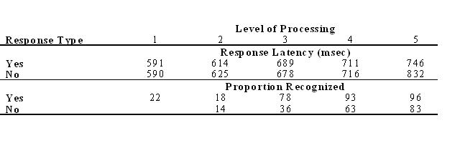
What do you notice about response latency (reaction time) as level of processing increased?

What can you say about the proportion of words recognized as level of processing increased?

5. Application to Social Psychology
For an application of levels of processing theory to Social Psychology, do the Experiment in Psychmate called “Levels of Processing and the Self-Reference Effect,” page3-23 in Psychmate, Student Guide. The self-reference effect refers to the finding that subjects demonstrate very good recall when asked to make judgments about whether words describe themselves. Recall on a self-reference task is superior to that on a semantic task. See fig 3.4.2 in Psychmate which illustrates this finding.
In the experiment you do, you will have four levels of processing. Identify what these 4 levels are.

6. In Excel, sort your data by level of processing, separately for “yes” responses and separately for “no” responses. Put your data in a table similar to the one above. (Your data will contain only the top half of the table above since you only were in a RT experiment and you were not asked to recall the words as Craik and Tulving did in their original experiment.)

7. What can you say about how percent recall of words studied changes as level of processing increases in your data?

8. Do an ANOVA to test for significance of your results.

Problem
Suppose someone is driving on the highway, reading the road signs, talking on a cell phone with the radio playing in the background (both music and talk). What types of processing are involved in each of these activities? What implications are there in what you learned today for the driver of the car?

